ROUTE 1 STEWARDSHIP PLAN (DRAFT)

South Kingstown, Rhode Island

Contents

Executive Summary 4
Acknowledgements 5
1. Introduction 6
Vision & Mission 6
Purpose 6
Stakeholders & Public Participation 6
2. THE CORRIDOR 8
Route 1 Past & Present 8
Physical Characteristics 8
Roadway 8
Utilization & Function 8
Traffic & Safety 8
Stormwater 8
Signage 8
Aesthetic Characteristics 8
Uniqueness 8
Harmony of Landscape 9
Integrity of Roadway 9
Vividness 9
Abutting Land Use 9
Residential 9
Agricultural 10
Commercial 10
Open Space 10
Intrinsic Qualities 10
Natural Qualities 10
Scenic Qualities 13
Cultural & Historic Qualities 14
Recreational Qualities 16
Susceptibility to Change 16
3. THE PLAN 18
Defining the Corridor 18
Goals & Objectives 18
Management & Protection Strategies 21
Protection 21
Maintenance 21
Enhancement 21
Action Items 21
Guardrails 22
Safety 22
Curb Cuts 22
Gateways 22
Development Guidelines adjacent to corridor 22
Lighting 22
Signage 22
Utilities 22
Stormwater Management 22
Enforcement of illegal improvements within Right-of-Way 23
Maintenance 23
4. Implementation 24
Appendix 25

ExecUtive Summary

AcknowledgEments

Introduction

Vision & Mission
Roadways serve invaluable roles for both the movement of people and goods, and the establishment of a community’s sense of place. Major roadways are often the primary way in which travelers see an area and serve as an introduction to the landscape, culture, history and amenities that define a place. U.S. Route 1 provides a daily opportunity for travelers to become acquainted with the values and resources that are South Kingstown. Effective stewardship of the scenic natural and cultural resources along the U.S Route 1 corridor will preserve the integrity of travelers views towards coastal waters, forests and fields, and the historic cultural features of South Kingstown throughout the seasons of the year. Management and maintenance of the roadway will enhance and sustain these valuable resources in ways that increase travelers' awareness of the unique cultural and environmental contexts that surround them.
“Preserve and enhance the corridors scenic values including the physical and aesthetic characteristics and intrinsic qualities for the residents, visitors and abutting property owners.”

Purpose
The purpose of this Plan is to formally recognize the value of the natural and cultural features along the U.S. Route 1 corridor in South Kingstown. The Town recognizes that preserving the scenic qualities of the corridor which contributes to a positive sense of place that is aligned with the Town’s Comprehensive Plan, thus the Stewardship Plan serves to provide guidance and recommendations for the protection and preservation of the scenic character of Route 1 within South Kingstown.
In addition to rich natural features, a mix of residential, commercial, and agricultural land uses currently exist in direct proximity to U.S. Route 1 which add to a positive and diverse range of activities along the roadway corridor. The intent of this Stewardship Plan is not to alter the existing land uses or unduly limit the rights of abutting residential or commercial property owners. Moreover, the intent of this Plan is to insure that changes to land abutting the Route 1 corridor do not overwhelm and compromise the integrity of the natural and cultural qualities of the road to the detriment of the experience of all who travel the road.
The purpose of this Plan is to preserve, maintain, and enhance the quality experience within the Route 1 corridor that provides enjoyment and enrichment for residents and visitors alike., The road shall continue to serve as a reflection of the natural beauty and historic significance that makes South Kingstown such a special place.

THE CORRIDOR

Route 1 Past & Present
US Route 1 through the Town of South Kingstown, Rhode Island is arguably a reflection of history in its own right, with prehistoric origins associated with Native American trails for travel, hunting, and defense, early European colonists for access to homesteads, mail, and news, as well as for efficient travel and commerce by motorized vehicles in contemporary times. Its affiliation with and name as the “Post Road” and in some sections as the “Commander Oliver Hazard Perry Memorial Highway” in other sections reinforces its important origins and a local resident prominent for his achievements in the War of 1812.
As early as 1702, following the Pequot Purchase of land by colonists from the local native tribe, a Committee was set up by the then Town of Kingstown (present South Kingstown and North Kingstown) to determine a network of roadways to serve the newly acquired land for homes, farms, and early commerce. The so called “Pequot Trails,” interconnected with newly developed road sections became the passable corridors that serve as the paved roadway systems that exist today in South Kingstown and adjacent Towns.
The general corridor of present-day Route 1A reflects more closely the initial “Old Post Road” alignment that the early 1700’s Committee outlined. Only in certain segments does the present US Route 1 overlay portions of Route 1A, primarily between the Moonstone Beach Road and Jerry Brown Farm Road intersections.
The current Route 1 corridor was established and “signed accordingly in Rhode Island by 1926.” This appears to have been a federally led requirement that each State from Florida to Maine had to identify and designate the roadways that make up the entire length of the corridor. It is notable that the presence of some commercial development as well as natural and marine frontage on the Route 1’s corridor through South Kingstown captures elements indicative of its entire length.
Route 1, while a two lane, divided highway maintains a 50 mile per hour speed limit from the northern South Kingstown town-line to the point of entry into Charlestown, encouraging a somewhat slower highway pace. This feature provides an opportunity to responsibly take in the features that define its past from the boulder strewn woodlands from the recession of the last glaciers, the natural woodlands, wetlands, and coastal ponds to historic farms, stone walls, and buildings and landmarks on the National Register of Historic Places.
In one sense, the proximal, presence of Route 1A, weaving north, south, and east in proximity to the four-lane Route 1 corridor provides favorable access to the landscape, coastal, and historic features for those interested in exiting the highway and exploring these sites and features. Through an effective signage system, or conceivably, with a more sophisticated GPS-based guidance and narration tool, motorists could learn information as they drive the Route 1 corridor or as they follow directions to view the site or feature for themselves.

Physical Characteristics

Roadway
Route 1, particularly the stretch of roadway south of the Narragansett town line, was constructed in such a way as to enhance the sense of the natural topography. To the north lies the terminal moraine and to the south, the outwash coastal plains. Situated between both geologic features, the road curves to follow the topography while providing scenic views.
In some areas the north and southbound lanes are tiered which permits wonderful views of the horizon. A variety of types and cover of medians are present. They range from a short section of concrete barrier to more aesthetically pleasing vegetated medians. Vegetation within medians varies from maintained grass areas to planted areas to naturally vegetated medians. In 2011, RIDOT removed some of the vegetation to install a wire barrier to ensure safety and prevent less attractive options.
Route 1 is categorized by the State of Rhode Island as a Multilane, Fully Controlled US Highway. The nearly 13 mile section stretches through Town beginning near the Route 138/Bridgetown Road intersection heading south to Shannock Road. Within the Town of South Kingstown, the highway right-of-way has a varying width from approximately 150 feet at the northern most section to nearly 400 feet wide in sections south of the downtown exits. The highway consist primarily of two 12-foot travel lanes in both directions with an 11-foot shoulder along the outside travel lane and a 2-foot shoulder on the inside. North of the downtown exists the highway includes a somewhat narrow (approximately 10-foot wide) center island with a wire guardrail traffic protection device and drainage conveyance. South of the downtown exits, the land area opens up enough to allowing for a very wide center island.
According to the Rhode Island Department of Transportation, combined north-south traffic volume between the Route 138 intersection and the downtown exits ranges between approximately 16,000 vehicles-per-day in late spring to over 35,000 vehicles-per-day through the summer months. Combined volumes further south average 19,000 vehicles-per-day. In recent years, due to traffic volumes and in response to safety concerns, RIDOT performed roadway improvements near Saugatucket Road, approximately 2-miles north of the downtown exits. The improvements include resurfacing with a high friction wearing material. The added surface material will help vehicles maintain traction. RIDOT continues to monitor the roadway for potential conflicts and plans to make further improvements as necessary.
Access to Route 1 is mixed and includes acceleration/deceleration ramps, direct street access, and in some situations, direct driveway access. The posted speed limit is 50 miles-per-hour throughout the entire roadway section. Between the northern intersection at Route 138 to the Stedman Government Center, U-turn maneuvers are allowed at right lane jughandles with traffic lights. U-turn maneuvers are provided with right lane exit ramps and overpass bridges at the Wakefield Business and Narragansett Exits. Locations further south allow for U-turn maneuvers at large sweeping left lane turn-a-rounds within the center island.

Gateways (northern terminus and southern terminus)

Traffic & Safety

Stormwater

Signage

Existing Signage
A visual inspection of Route 1 (Commodore Oliver Hazard Perry Highway) informs the traveler through a proliferation and abundance of signage. Examples of such signage is demonstrated through the typical regulatory and warning signs (red, yellow and black &white signs), informational and services signs (green and blue signs), recreation and scenic guidance signs (brown), and the occasional construction sign (orange). In addition to these Federally regulated signs, Route 1 also hosts a multitude of other signs – for sale/lease signs, local business signs, farm stand/landscape business signs, as well as neighborhood signs, to name a few.

As may be expected, the number of signs as well as the density of location of signs increases near an exit of various opportunities. For example, when a traveler approaches the exit to access “Historic Wakefield” heading south, there are multiple signs competing for the drivers attention. This is not only apparent at these busier exits; there are several locations along Route 1 where Federally regulated signs are competing for the drivers attention – so much so that signs appear to overlap one another, even once the driver is close.
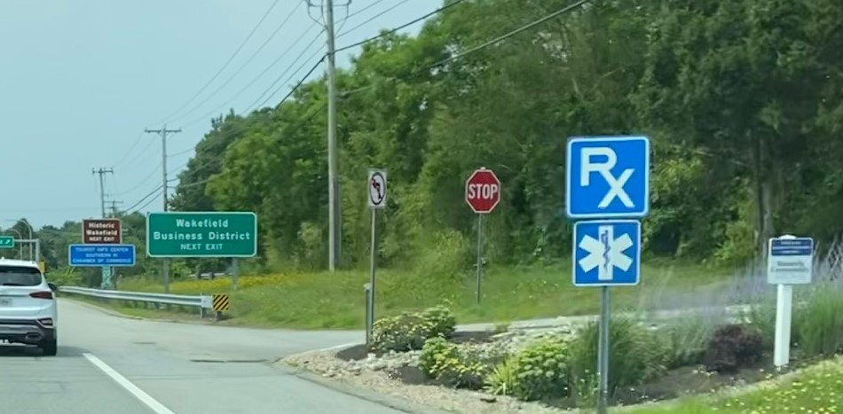
Figure 1: Route 1 Southbound at the Wakefield Exit
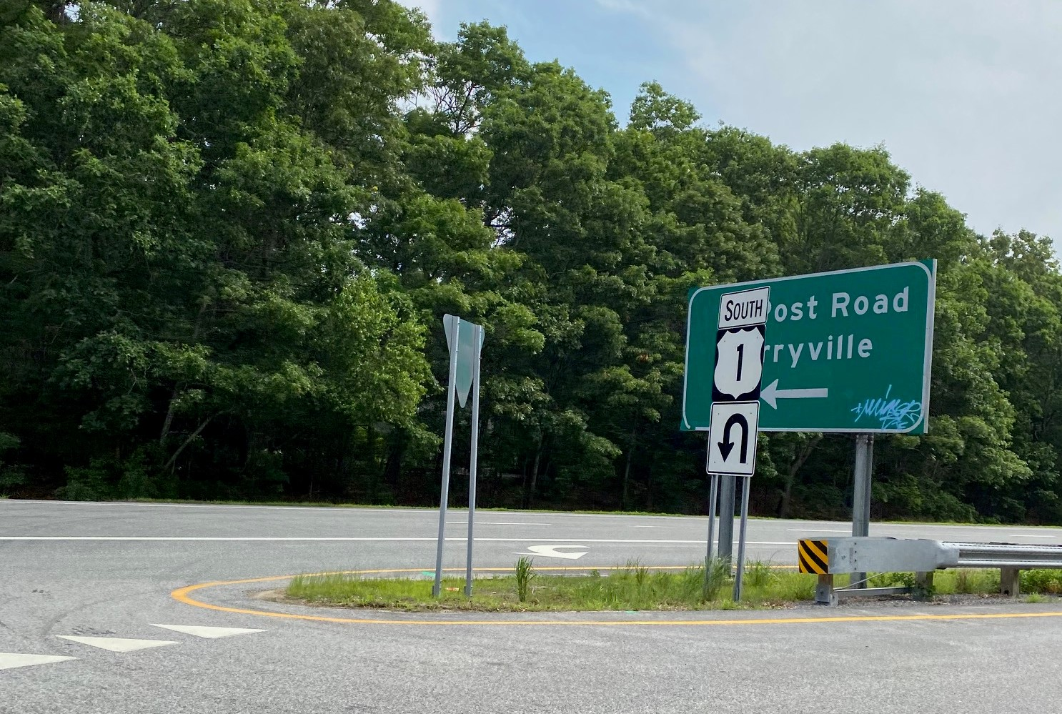

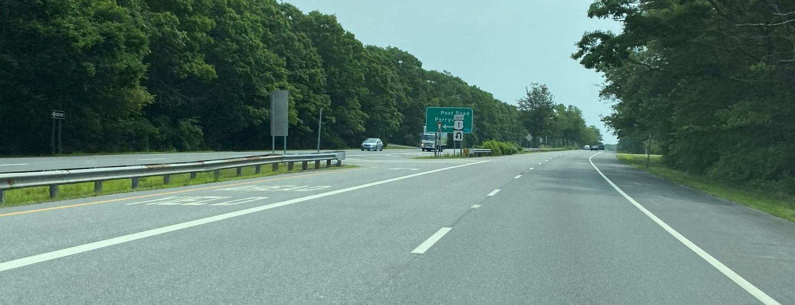
Figure 2: Perryville Exit headed Northbound. Overlapping signage obstructs the Informational sign. Also there is graffiti on the sign.

Route 1 hosts a plethora of warning signs. There are U-Turn signs, ‘lane ending’ signs, ‘lane merge’ signs as well as one-way arrows and yield signs at virtually every turn on or off Route 1 in both directions. Signage is often redundant for the same exit/turn.
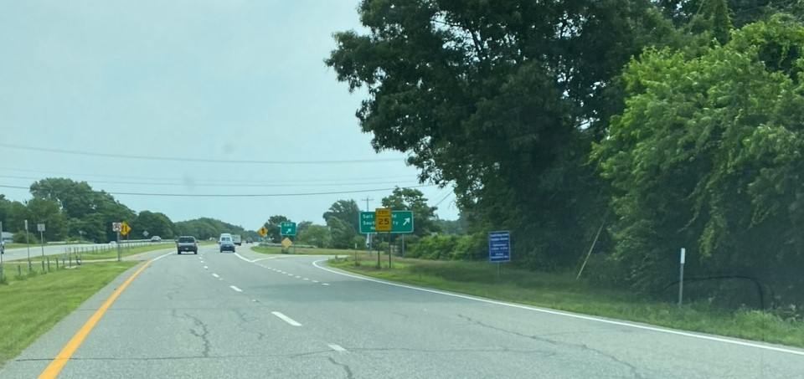
Figure 3Rte 1 heading north. Multiple directional and instructional signs in one area.

In recent years, it seems that the abundance of warning type signs has increased. There are lane end signs, lane merge signs, as well as reduced speed signs for exits.
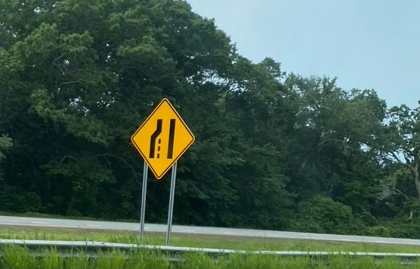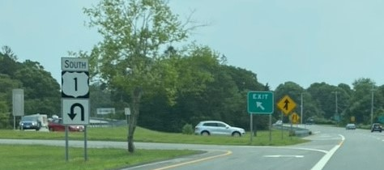
The scenic qualities of Route 1 are most directly affected by the type, location, and proliferation of signage on this highway. Reducing, limiting, and creating coordinated and consistent signage will greatly add to the scenic nature of the highway and will ultimately benefit the traveler.

SAFETY SIGNAGE: In recent years the official safety signage along the route has greatly proliferated. Rumor has it that private signage companies do the installation and charge the state a rental fee. If so, there is a profit for the more signs that go up. I am checking this out with RIDOT, Scenic America and other sources.
INFORMATIONAL SIGNAGE:
Official: What now exists? Photo examples. What could be if we copied what is done in some other areas.
Locally installed: Temporary for events etc. Permanent: photo examples
BILLBOARDS: There are two billboards, one can be seen as travelers are headed southbound just south of Tower Hill/138 intersection. Whose property is it on? When was it installed? State regs re: billboards. The other billboard is on the northbound side of Route 1, in Matunuck, but it can more easily be seen from the southbound lanes.

Overhead Utilities: Can we add this? Scenic America is working on this issue and we will be in touch with the staff person tomorrow to learn more.

Aesthetic Characteristics

Uniqueness
One unique feature of Route 1 is the diversity of landforms. The juxtaposition between the Charlestown Moraine and the outwash plains left by the last glaciers to cover New England provides an outdoor geology display for motorists. Along with diverse typographical features, the road’s proximity to bodies of open water of the bay and coastal ponds affords exceptional views in all seasons. As noted above, the Atlantic White Cedar shrub bog at Factory Pond with its dwarf tree forms is the only example of this natural community within Rhode Island.

Harmony of Landscape
For approximately two miles after the Oliver Stedman Government Center there is some commercial and residential development abutting the highway. However, many of these properties are landscaped with a vegetated buffer to shield them from view of the roadway.
Most of the parcels adjacent to Route 1, although zoned for low and medium-density development, are not yet developed. This provides for a feeling of open space and rural character uncommon to many areas in Rhode Island.

Integrity of Roadway
Route 1 is a four-lane roadway with a grass and forested median running its entire length, excepting several hundred feet on the Wakefield 'cut-off' overpass.
The roadway is characterized by rolling hills in the northern section and gentle curves in the south which contribute to the roadway and landscape aesthetics. Neither hills nor curves pose hazards for vehicles traveling at designated speeds. Ample shoulder widths allow vehicles to pull safely to the side of the road for emergencies.
Tiered lanes and diversity of vegetation within the medians also serve to enhance the character of the roadway.

Vividness
The diverse topography, vegetation and land uses located along Route 1 create vivid impressions for motorists. Examples of these include:
- The frequent roadway curves are in concert with glacial deposits;
- Irregular hills in the north and the low hills in the outwash plain provide horizon vistas;
- The diverse types of water bodies - coastal ponds, inland lakes, and Narragansett Bay - provide contrasting views that compliment vegetated areas; and
- The frequency of diverse wetlands along the highway form dense areas of greenery during summer and vivid contrasts of gold, yellow and red in autumn.

Abutting Land Use

Residential

Agricultural
At least ten of the agricultural parcels located along Route 1 are currently in use. Another eight properties are conserved through the town-administered Farm, Forest, and Open Space program that reduces tax assessments on agricultural land for periods of fifteen years (South Kingstown Comprehensive Plan). Highland Farm and Clark Farm Nursery are other noteworthy active agricultural properties located along Route 1.

Commercial

Open Space

Intrinsic Qualities

Natural Qualities & Resources

Vegetation
Route 1 in South Kingstown offers motorists a lesson in native habitats and agrarian landscapes. Depending on physical characteristics including soil conditions that can vary from hydric (wet) to mesic (mixed) to xeric (dry), elevation and past use, the vegetation along the road displays diverse plant communities. These include upland deciduous, coniferous and mixed forests, scrub shrub communities and herbaceous species.
The generally low-level elevation, particularly of the coastal plain, allows long vistas across marshes and estuaries and their sedges, rushes and grasses. Coastal hardwood forests support black, red and white oaks, hickories, and black cherry. In the hills and lowlands to the north of the road are oaks, hickories, other hard woods, some hemlock and white pine. Ash and red maples grow in the forested wetlands beside the road. Rhododendron maxima – the native rhododendron – laurels, holly, blueberry, huckleberry and spicebush thrive in the understory of forested wetlands.
The Atlantic white cedar shrub bog at Factory Pond with its dwarf tree forms is the only example of this natural community within Rhode Island. Groves of pitch pine flourish at various locations, particularly on the north side of the roadway in the dry sandy/gravelly soils left by the glacier. Wildflowers and grasses grow in the median section of the road.
The area south of the Wakefield cutoff is relatively free of exotics and other invasives, providing a unique opportunity to preserve this natural heritage. The area above the Wakefield cutoff has been less fortunate. Disturbances to the vegetation have allowed invasives and aggressive native vines to get a foothold. Invasives serve as an early warning system of potential threats to a community’s ecological integrity and speak to a need for careful landscaping where areas have been disturbed. Exotic plants as well as natives were introduced as part of roadway improvements of the past.
Additionally, several beech trees located in the State right-of-way in proximity to the Hale House were preserved in response to changes in the road alignment of Route 1 at the time. This action demonstrated the type of landscape practices that best support the natural and cultural resources along the Route 1 corridor.

Topography
Because of the past geological activity that has occurred in this region the location of the roadway, in close proximity to the ocean, has resulted in unique topography visible to motorists. Beginning at the more northerly end of town and traveling south along the highway, several distinct hills provide topographic relief from the more level road sections. The first of these is Tower Hill, followed by McSparran and Meetinghouse Hills. The hills occur within a short distance of one another and increase the variety of the landscape for motorists.
The portion of U.S. Route 1 in the eastern area of South Kingstown follows the western edge of the Narragansett Basin. This is a structural basin extending from the mouth of Narragansett Bay to Massachusetts.
The section of roadway in the southern area of town parallels the coastline and provides graphic topographic variations. The terminal moraine edge located on the north side of the roadway was formed by glacial activity during the most recent ice age. It provides the physical structure on which the planning for Route 1 seems to have been at least partially based. Occasional hills associated with glacial outwash interrupt the more gradual topography within the coastal plain, which stretches to the south from the highway (Quinn).

Surface Water
U.S. Route 1 is proximal to several bodies of water as it stretches through South Kingstown. The water bodies range from salt water to brackish water to upland fresh water ponds. These features afford motorists scenic views of unique and critical natural habitats within the region.
At Tower Hill motorists can see Narrow River and Narragansett Bay located to the east of Route 1. Conanicut Island (Jamestown) is visible in the foreground as is the Beavertail Light, at the southernmost tip of Jamestown. On clear days Aquidneck Island and the city of Newport can be seen in the distance.
Traveling south on Route 1, travelers have seasonal views of Indian Lake (winter) and the roadway passes directly by Silver Lake just below the Wakefield cutoff. Further south and located immediately past the Narragansett-South Kingstown town boundaries are upper Pt. Judith Pond to the south and Silver Spring Cove to the north. The upper reaches of Pt. Judith Pond house several marinas and the cove provides refuge to many species of waterfowl and wildlife (including an osprey nesting site). During the spring and summer months the cove abounds with the activity of recreational boating enthusiasts.
Mill Pond, just south of Route 1 near Ministerial Road, is a small body of water surrounded by marshes and forested wetlands. This is the site of unique plant communities and has been the subject of studies by the University of Rhode Island. Perch Cove is yet another water body visible from the roadway. The Cove, part of Potter Pond, includes associated vegetative communities that form a fringe around the open water area that present significant displays of autumn foliage.

Geology
The southern portion of U.S. Route 1 is located at the foot of the Charlestown Moraine, a result of glacial activity that extends from Wakefield to Watch Hill. The moraine, which is 150 to 200 feet in height, is a prime example of end moraine geological activity (RIHPHC). Rt. 1 is located at the juxtaposition of the moraine and associated coastal plain.
South of the Charlestown Moraine and U.S. Route 1 lie outwash plains, extending to the Atlantic Ocean. These plains formed through glacial melt water carrying vast quantities of soil which were deposited in stratified layers. This same glacial outwash, reworked by millennia of storms, tides and dynamic coastal processes formed the surrounding salt ponds and barrier beaches (RIHPHC, CRMC).
As noted by Alonzo W. Quinn: "Route 1, 'scenic route', is on the outwash plain just south of the moraine. As one drives west the 'knob and kettle' moraine is on his right side and the outwash plain slopes gently off to his left."
'Knob and kettle' moraine is a very irregular topography noted by hills of glacial till deposits and kettle ponds caused by large ice blocks melted and left distinct depressions in the landscape.

Wetlands
Much of U.S. Route 1 is located within the Coastal Resources Management Council's Special Area Management Plan (SAMP) for protection of coastal resources. The entire length of Route 1 north of the Wakefield cut-off forms the western boundary of the Narrow River SAMP region. The region identified in the Salt Pond SAMP requiring particular attention to the natural environment extends from the Atlantic Coast north to Wordens Pond and west from Pt. Judith Pond to Ninigret Pond. U.S. Route 1 bisects the entire SAMP region.
U.S. Route 1 crosses several distinct regions of wetlands, particularly in the northern portion. Extensive wetlands are present along the west side of the roadway and are associated with tributaries that feed Indian Run Reservoir. Deciduous forested wetlands dominate this region and are characterized by large stands of red maple as well as birch, ash, willow, and dogwood. An interspersing of shrub swamps in this same area provides for a mix of young trees, shrubs and other woody plants. Common varieties for New England shrub wetlands are alder, blueberry, swamp rose, arrow-wood, and spicebush.
In the southern region, wetland types include marshes, wet meadows, shrub swamps, and coniferous and deciduous forested wetlands. In addition to the trees and shrubs discussed above, the wetlands in the southern region of town also contain communities of hydrophilic grasses, sedges, rushes and other herbaceous plants found within wet meadows and marshes. Most of these wetlands are also associated with open water bodies.
Bogs are wetland areas of high acidity, low temperatures, and restricted drainage. One historic wetland feature known as the "Crying Bog" is located to the west of Route 1 as motorists cross the Route 108 overpass in Narragansett, and is associated with the Pettaquamscutt Cove watershed and Silver Lake. Vegetation unique and almost limited to bogs includes mosses, pitcher plants, leatherleaf, and bog laurel.
In the outlying Mill Pond region are a variety of wetlands types that include wet meadows, shrub swamps, and deciduous forested wetlands. The associated vegetative growth is similar to species aforementioned such as grasses, shrubs, and red maple trees.

Wildlife Habitat
The areas bordering U.S. Route 1 provide important habitat for numerous wildlife. The wide variety of ecological systems (i.e. mesic upland, xeric upland, and wetland) provides out-standing habitats for fish, bird, mammal, reptile and amphibian populations. Extensive linear edges between upland and wetland areas results in a significant so-called 'edge effect' that wildlife biologists note as having great importance as habitat.
Species observed within the uplands includes a variety of passerine birds (i.e. robins, finch, sparrows, and other songbirds), reptiles (i.e. turtles), small mammals (i.e. shrew, vole, foxes, coyotes, and deer) and birds of prey (i.e. turkey vulture, red tailed hawk, and osprey). Both the fresh water and salt water wetland systems provide abundant habitat for a myriad of fish, mammals, reptiles, amphibians and water fowl. Empirical data collected identifies a multitude of fur bearing mammals (i.e. raccoon, skunk and opossum) that also utilize the vegetated median areas.
Two Natural Heritage Areas occur along U.S. Route 1 in South Kingstown. Natural Heritage Areas are regions that provide habitat for rare and endangered species as delineated by the Department of Environmental Management. The first of these areas is the Tucker Pond region, which is one of the more unique regions in the state for aquatic vegetative species (Conversation with Rick Enser, RIDEM, May 1996). Most sites for endangered species in this area occur at Tucker Pond and Long Pond, located north of the highway however the southern border for the entire region under protection is the highway. The second Natural Heritage Area that borders U.S. Route 1 is associated with Factory Pond and Potter Pond. (Conversation with Rick Enser, RIDEM, May, 1996)

Specially Regulated Areas
The areas bordering

Scenic Qualities

Vistas
Route 1 provides exceptional vistas through its entire length. Pastoral scenes, ocean and pond views, inland water bodies, wetlands and stands of conifer and hardwood trees are among the many splendid scenes afforded motorists. Prime examples are:
- Along the roadway near Tower Hill are panoramic vistas of Narragansett Bay, the Atlantic Ocean, and the bridges that span the western and eastern passages of Narragansett Bay;
- South of this area are seasonal views (winter) from Route 1 west to Indian Lake;
- Further south are stretches of fields, pastures, and farmlands. Rolling hills provide scenic views of the surrounding town and large stretches of woodlands; and
- Upper Pt. Judith Pond, replete with several marinas, a variety of vessels and extensive pristine wildlife habitats is visible just beyond a building that houses the Town’s Public Services Department. Adjacent to the marinas is Marina Park - a town facility that provides passive recreation for residents and accommodates seasonal festivals and other activities.

Cultural & Historic Qualities

Agrarian History
South Kingstown's history as an agricultural community has its roots in the early settlements of Narragansett Indians who first cleared and cultivated the land (RI Historical Preservation and Heritage Commission - RIHPHC). Continued preservation of extant agricultural land is important to retain the town's rural character, to maintain open space, and to provide a sense of place for residents.
This agricultural heritage becomes apparent to motorists as they encounter the many working farms, agricultural parcels, and stonewalls located along the highway. The Weeden farmhouse and the surrounding farm - 'Willow Dell', are located just south of U.S. Route 1 just west of Matunuck Beach Road. The farm was once part of a 600 acre tract that extended to the Atlantic Ocean (RIHPHC). 'Willow Dell' was recently designated for listing on the National Register of Historic Places.
Approximately two miles north of 'Willow Dell' is the Whaley Farm produce stand. The stand marks the entrance to Whaley Farm, a 19th Century complex of farm, outbuildings, and fields located just south of Route 1.
Rocky Meadows Farm dates back to the 1750's and is located approximately one-half mile east of Whaley Farm on the south side of the highway. North of Rocky Meadows near the intersection of Post Road lies a property know as Jeremiah Robinson House/Endelar with an agrarian landscape and elaborate Queen Anne dwelling. Shadblow Farm is a preserved farmland approximately 2 miles north of the Wakefield cutoff and contains a historic federal farmhouse. Rocky Meadows Farm, Jeremiah Robinson House/Endelar, and Shadblow Farm are all properties eligible for listing on the National Register.

Historic Features
The modern roadway follows, in large measure, the Revolutionary road colonists built on the former Indian trails to carry mail and the newspapers that united the colonists from New York to Boston in the ferment that became the revolt against the British. Other parts of the Post Road predominantly in other states have succumbed to the pressures of commercialization, but the section in southern Rhode Island retains more of the roadway’s historic character.
Today, a wide-range of historical sites from the 18th and 19th Centuries can still be found adjacent to Route 1. Several structures have or are eligible for listing on the National Registry of Historic Places. Some of the more distinctive places are listed below.
- The Observation Tower and Hannah Robinson Rock at Route 138 was the site of a historic stone lookout used since about 1739. The current tower was built in 1936.
- The Helme-Torrey Cemetery (South Kingstown Number 26), which dates back to 1746, lies at the corner of Torrey Road and Route 1.
- Two historic markers are found on U.S. Route 1: (1) The “Carter Killed Jackson” monument marks the site of a murder committed in 1751; and (2) The Wager Weeden Watering Place is a stone marker and watering trough at the entrance to Weeden Farm commemorating the arduous task of transporting water faced by 19th Century farmers.
- The Jeremiah Robinson House/Endelar with an agrarian landscape and elaborate Queen Anne dwelling which is eligible for listing on the National Register.
- Using hydropower of the Mill Pond is the Samuel E. Perry Grist Mill. Built in 1703, this landmark property is the water-powered mill still operating in Rhode Island which has been in continuous service since the 18th Century.
- Willow Dell, the Weeden Farm farmhouse, was built in 1793 and is listed on the National Register of Historic Places.
- The Robert Beverly Hale Library, built in 1896, continues to serve as the local library for Perryville and South Shore residents.
- The Edward Everett Hale House, built in the 1870s in the Italianate, second Empire style, has been restored and is now conserved by the Pettaquamscutt Historical Society and open to the public. Edward Everett Hale was an author and clergyman from Roxbury, Massachusetts, who summered in the Matunuck for about 40 years with his house forming the seat of an extensive artist community that also resided in the Matunuck Hills. The Hale House is on the National Register of Historic Places.
- An archeological site referred to as RI 110 that lies just off Route 1 has been identified and will be preserved. The site contains rare evidence of Narragansett Indian Tribe daily life before the arrival of Europeans. The site is unmatched on the Eastern seaboard with most features dating from the year 950 to 1550.
- Much of the U.S. Route 1 corridor follows the historic Post Road the colonists used to carry mail and newspapers. This roadway was initially built on Indian trails that were used by native inhabitants for centuries prior to the colonial era. The corridor itself represents an archeological feature that provided an important means of transportation for the indigenous populations of the region.

Stone Walls
Winding throughout South Kingstown are many miles of stonewalls, vestiges of the town's long agrarian history. Approximately four miles of stonewalls parallel U.S. Route 1, with many more miles of wall running perpendicular from the highway and within motorists' views. More than three miles of wall parallel U.S. Route 1 between Tower Hill and the Wakefield cutoff.
It is believed that these walls located south of Tower Hill were constructed by slaves owned by the "Narragansett Planters," a wealthy aristocracy of the 17th and 18th Centuries who built palatial agrarian estates reminiscent of the ante-bellum south. The walls form a border between Route 1 and the western property lines of parcels once part of the large plantations that extended to the Pettaquamscutt (Narrow) River (RIHPHC).

Points of Interest
In addition to the historic features discussed above, including miles of stone walls visible from roadway, Route 1 hosts a variety of man-made structures that chronicle the Town’s past and support its current activities. Some of these significant sites visible from or adjacent to the road are listed below.
- Several 18th Century houses including Brookfield, the John Potter house, aka the Great House, built about 1730, and the Rocky Meadows Farm house from 1754.
- Several 19th Century houses including Hidden Hearth one of several houses for a community of artists who summered in the Matunuck Hills, and the Jeremiah Robinson house build by Stanford White of McKim, Mead and White.
- Camp Fuller, the second oldest organized youth camp in the world (RIHPHC).
- Clark Nursery, Whaley Farm stand and Highland Farm, examples of green industry that supports the economy of South Kingstown.
- Town Farm Park with baseball fields.
- Marina Park, a town facility along the shores of Upper Pt. Judith Pond, provides passive recreation for residents and accommodates seasonal festivals and other activities (weekly farmer’s market in season).
- The South County Hospital and Health Care System Facility.
- The Oliver Steadman Government Center, the Tourism office, the South County Chamber of Commerce and the TSK’s Public Services building.
- The Fire Station at Saugatucket Road.
- URI’s Sailing Center and its Robert P. Arrigan Memorial Sailing Pavilion, the Stone Cove Marina.
- Several housing communities such as Indian Lake Shores, Spartina Cove, and Wakefield Meadows, a community for those over 55.
- Three private schools, Monsignor Clarke, Prout and Bradley.
- Several burial grounds, including Helme-Torrey and Perryville Quaker (#65).
- South County Commons, the Route 1 Special Management District.
- Several seasonal farm stands/markets abut the roadway including Clark Farms, Whaley Farm, Marina Park (Farmers Market), Highland Farm, and Carpenters Farm.

Alternative Methods of Transportation

Susceptibility to Change
U.S. Route 1 has maintained its rural and historic character because many of the parcels abutting the roadway have not been developed. The town has attempted to reduce potential adverse impacts through conservative zoning patterns. The vast majority of the land is zoned R40, R80, and R200 (approximately one, two, and five acre lots for residential development).
Route 1 is most heavily traveled during the summer months. The roadway provides access to many public and private beaches including Narragansett, Scarborough, Matunuck, East Matunuck, Moonstone, and Green Hill. Other seasonal recreation and cultural facilities accessed by Route 1 in South Kingstown include Theater by the Sea, the Port of Galilee, Block Island Ferry, Trustom Pond National Wildlife Refuge, and the Hale House.
Because of inclusion within the CRMC SAMP regions, much of the land located along U.S. Route 1 is under more stringent regulations for future development. CRMC has certain authority to regulate types and intensity of development within SAMP regions.
A Groundwater Overlay District, to protect the Town water supply wells near Factory Pond, is located within the South Shore area. This measure restricts the types and intensity of land uses in reservoir and recharge areas.
One of the most pervasive threats to biodiversity is the spread of exotic or invasive species. Route 1 currently has several extraordinary examples of natural communities containing predominately natural species. This is especially true for the portion of the road south of the Wakefield cut off. Above that, disturbance of the land has allowed a foothold to invasives.
Add potential pressures for change in the commercial and institutional areas of the roadway (SCH?).

The Plan

Defining the Corridor

Goals & Objectives
Remember: GOALS represent the broad, long-term, desired result.
OBJECTIVES are the specific, measurable actions to be taken to achieve the goal.
Taken from the Stewardship Plan Outline
Topic 1 - Address design improvements within the boundaries of the State right-of-way for U.S. Route 1.
The Stewardship Plan should articulate recommendations for consideration by State agencies relating to proposed roadway improvement plans, including design features such as: roadway access/exit points, signage, lighting, landscaping, median and shoulder treatments, and u-turn intersections. Based on initial Planning Board review, potential examples of such recommendations may include:
- Improve aesthetics for and limiting the number of RIDOT signs to reduce visual clutter and standardize signage design;
- Improve design of RIDOT improvements, including design of lighting and guardrails;
- Encourage green infrastructure over traditional stormwater management techniques;
- Encourage the use of native landscaping materials used within the medians; and
- Investigate the creation of a long-term vision for active transportation and scenic vista management along the corridor.
The Plan should articulate recommendations for amendments to the Town’s Comprehensive Community Plan as a means to highlight the roadway’s scenic character as shared community asset, its economic and cultural significance to the Town, and defining the Town’s commitment to protecting and enhancing its scenic values.
The Plan should not recommend actions that will reduce the safety of the roadway.

The following information (within light blue text boxes) are the four (4) topics previously presented to the Town council outlining what topics the Stewardship Plan should consider.
The Goals following each topic, in blue text, are draft/sample goals that Staff has created based off the topics for consideration.
Goal 1: Increase the traveler experience by preserving the corridor’s natural setting and enhancing its aesthetic appeal through specified design improvements within the right-of-way and the creation of development guidelines along the corridor.
Blurb about Goal 1 as outlined above….
-----------------------------------------------------------------------------------------------------------------------------------------
Goal 2: Advocate for maintenance practices that showcase the corridors natural and built environment, and ensures that the roadway and associated landscaping treatments provide users a pleasing and notable experience.
Taken from the Stewardship Plan Outline
Topic 2 - Address maintenance practices within the boundaries of the State right-of-way for Route 1.
The Plan should articulate recommendations for consideration by State agencies relating to maintenance practices within the U.S. Route 1 State right-of-way, including issues relating to general roadway maintenance and the upkeep of landscaping, medians, shoulders, and access/exit points.
The Plan should address the need to limit disruption and disturbance stemming from construction activities that may impact visual resources
Blurb about Goal 2 as outlined above….
-----------------------------------------------------------------------------------------------------------------------------------------

Goal 3: Prevent and/or limit the potential for change to adversely impact the existing cultural, historic, or intrinsic qualities of the corridor.
Taken from the Stewardship Plan Outline
Topic 3 - Address potential changes to U.S. Route 1 that could impact the roadway’s scenic character, including abutting residential and commercial land uses.
The Plan should articulate recommendations for identifying and preserving existing scenic features, such as vegetative buffers, significant and mature trees, native shrubs and rare plants, stonewalls, and historic and cultural resources, within abutting areas.
The Plan should articulate recommendations for design elements of abutting areas such as signage placement, amount and design, management of curb cuts/access points, management of invasive species, and general maintenance practices.
The Plan should provide general guidance to inform future development activities on abutting properties in order to increase design sensitivity to features that may impact the scenic character of the roadway. This may result in recommendations for amendments to the Town of South Kingstown Zoning Ordinance and/or the Town of South Kingstown Subdivision and Land Development Regulations, depending on the goals of the final Stewardship Plan. Based on initial Planning Board review, potential examples of recommended amendments may include:
- Consider amending the Zoning Ordinance to ensure the protection of existing stone walls along the U.S. Route 1 highway line on parcels proposed for private commercial or residential development;
- Consider amending the Zoning Ordinance to require increased setbacks (potentially determined based on a percentage of total lot depth), and curved driveways for new single-family homes;
- Consider amending the Zoning Ordinance and the South Kingstown Subdivision and Land Development Regulations to require that new major subdivisions and land development projects preserve prominent viewsheds by increasing setbacks (similar to those already required for the Route 1 Special Management District), and limiting the number of new curb cuts; and
Consider amending the Zoning Ordinance to limit the installation of invasive landscape species on private property.
Blurb about Goal 3 as outlined above….
-----------------------------------------------------------------------------------------------------------------------------------------

Goal 4: Educate and engage government entities, local agencies, and public stakeholders to ensure that the concepts and recommendations listed within this Plan are implemented and achieved.
Taken from the Stewardship Plan Outline
Topic 4 - Address the roles and responsibilities for units of government and other stakeholders with regard to the stewardship of U.S. Route 1.
The Plan should establish the Town of South Kingstown as the primary steward for the U.S. Route 1 Scenic Roadway. In this role the Town would work closely with the RI Scenic Roadways Board, RI Department of Transportation, other state and federal agencies, area businesses, tourism interests, private land owners and other stakeholders to identify and pursue the common goals for the roadway.
The Plan should articulate the roles and responsibilities of local Boards/Commissions and Town Administration in the review of proposals affecting the U.S. Route 1 corridor.
The Plan should provide general guidance to the RI Department of Transportation and the RI Scenic Roadways Board in their development and review of any roadway improvement plans related to U.S. Route 1
The Plan should develop a program of public information and owner outreach education to provide a platform for community members to assist with roadway stewardship.

Blurb about Goal 4 as outlined above….
-----------------------------------------------------------------------------------------------------------------------------------------

Management & Protection Strategies

Protection

Maintenance

Enhancement

Action Items

Guardrails

Safety

Vehicular Safety

Turn-arounds (U-Turns)

Bicycle & Pedestrian Safety

Curb Cuts

Gateways

Development Guidelines adjacent to corridor

Lighting

Signage

Wayfinding

Commercial

Billboards

Utilities

Stormwater Management

Green infrastructure

Enforcement of illegal improvements within Right-of-Way

Maintenance

Mowing

Management of invasive & native species (wildflowers; native grasses)

Implementation

Appendix

